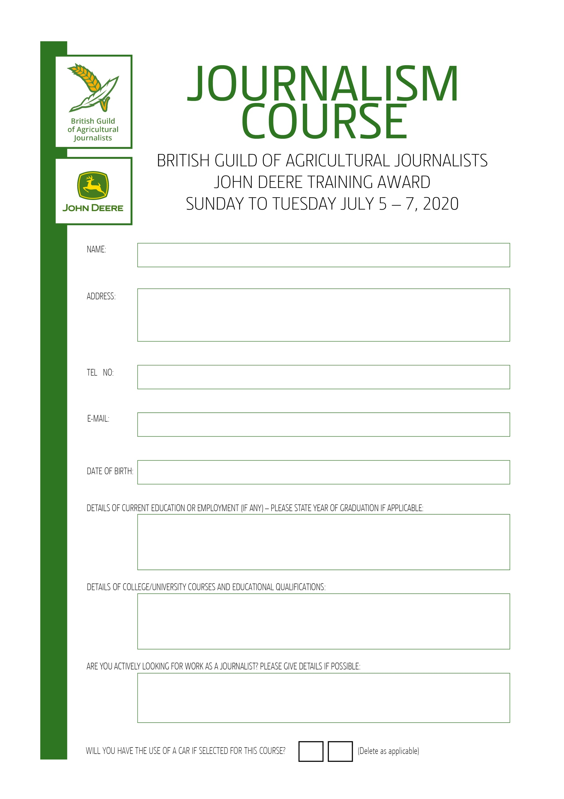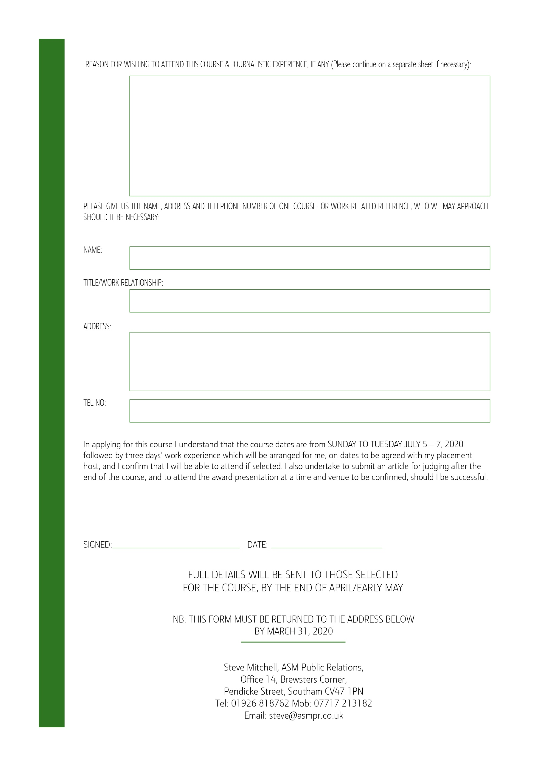

text

NO

YES

text

text

text

text

text

text

text

text

text

text

text

text

text

text

text